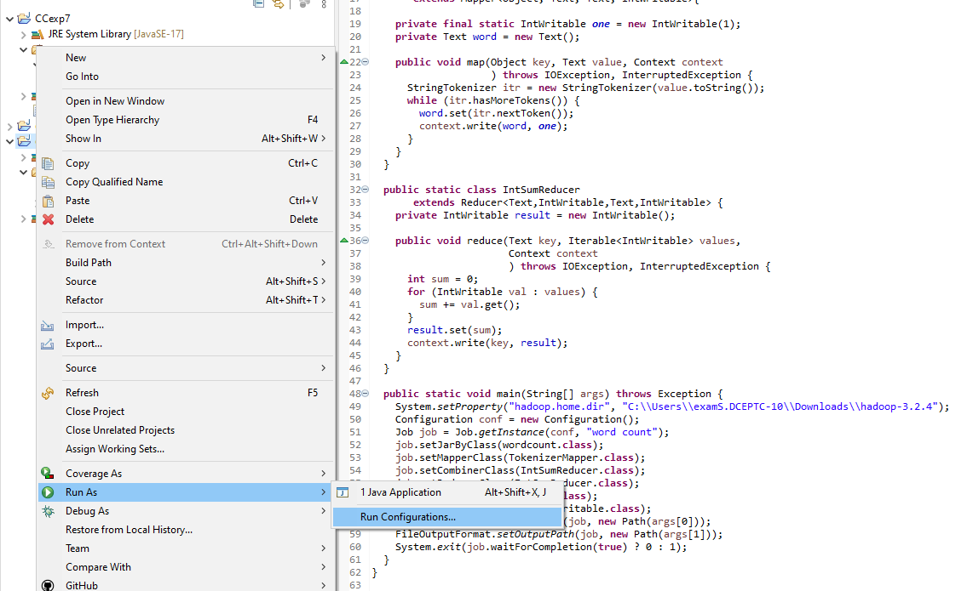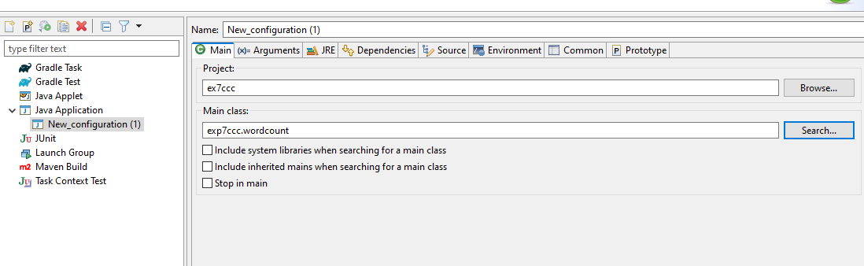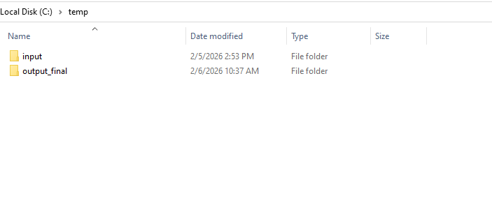

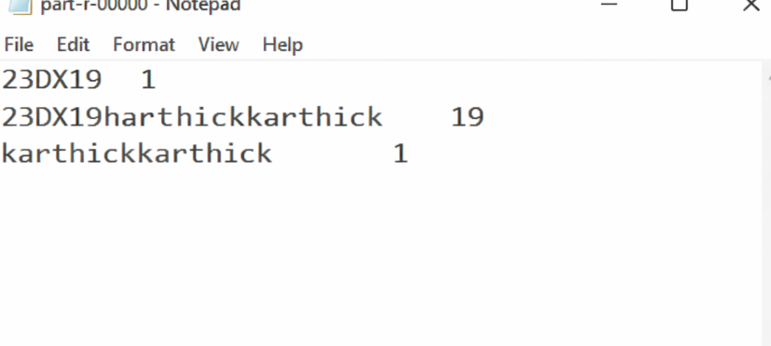

Wordcount.java
package exp7ccc;
import java.io.IOException;
import java.util.StringTokenizer;
import org.apache.hadoop.conf.Configuration;
import org.apache.hadoop.fs.Path;
import org.apache.hadoop.io.IntWritable;
import org.apache.hadoop.io.Text;
import org.apache.hadoop.mapreduce.Job;
import org.apache.hadoop.mapreduce.Mapper;
import org.apache.hadoop.mapreduce.Reducer;
import org.apache.hadoop.mapreduce.lib.input.FileInputFormat;
import org.apache.hadoop.mapreduce.lib.output.FileOutputFormat;

public class wordcount {

public static class TokenizerMapper
extends Mapper<Object, Text, Text, IntWritable>{

private final static IntWritable one = new IntWritable(1);
private Text word = new Text();

public void map(Object key, Text value, Context context
) throws IOException, InterruptedException {
StringTokenizer itr = new StringTokenizer(value.toString());
while (itr.hasMoreTokens()) {
word.set(itr.nextToken());
context.write(word, one);
}
}
}

public static class IntSumReducer
extends Reducer<Text,IntWritable,Text,IntWritable> {
private IntWritable result = new IntWritable();

public void reduce(Text key, Iterable<IntWritable> values,
Context context
) throws IOException, InterruptedException {
int sum = 0;
for (IntWritable val : values) {
sum += val.get();
}
result.set(sum);
context.write(key, result);
}
}

public static void main(String[] args) throws Exception {
System.setProperty("hadoop.home.dir", "C:\\Users\\examS.DCEPTC-10\\Downloads\\hadoop-3.2.4");
Configuration conf = new Configuration();
Job job = Job.getInstance(conf, "word count");
job.setJarByClass(wordcount.class);
job.setMapperClass(TokenizerMapper.class);
job.setCombinerClass(IntSumReducer.class);
job.setReducerClass(IntSumReducer.class);
job.setOutputKeyClass(Text.class);
job.setOutputValueClass(IntWritable.class);
FileInputFormat.addInputPath(job, new Path(args[0]));
FileOutputFormat.setOutputPath(job, new Path(args[1]));
System.exit(job.waitForCompletion(true) ? 0 : 1);
}
}

